**OS Assignment 2**

**Part A**

echo "Hello, World!"

Will print Hello World.



name="Productive"

Will save Productive in string name and can be print using $name

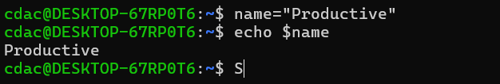

touch file.txt

Will create a new file named file.txt in the directory

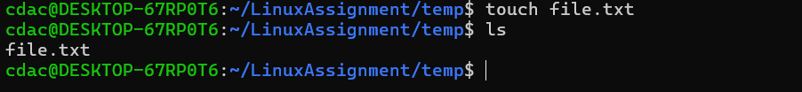

ls -a

It is used to show the hidden files in the directory

rm file.txt

It is used to delete a file from directory

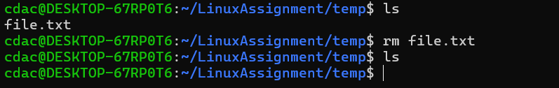

cp file1.txt file2.txt

It is used to copy files



mv file.txt /path/to/directory/

It is used to move a file to new directory

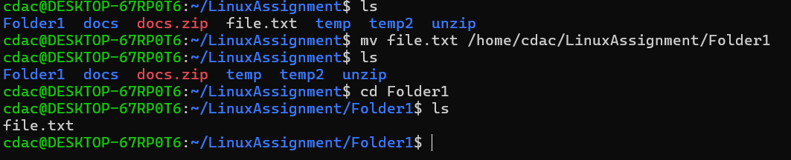

chmod 755 script.sh

This command allows everyone to read and execute the file, the owner is allowed to write to the file.

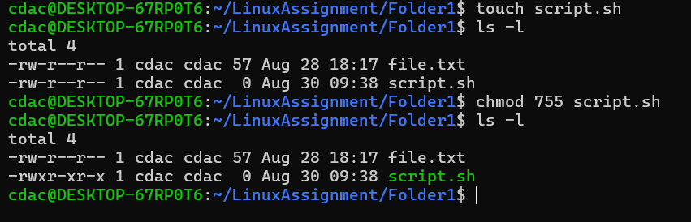

grep "pattern" file.txt

This command is used to find particular word in the file.



mkdir mydir && cd mydir && touch file.txt && echo "Hello, World!" > file.txt && cat file.txt

By using this command directory named mydir is created and cd is used to open the directory and then file.txt is created

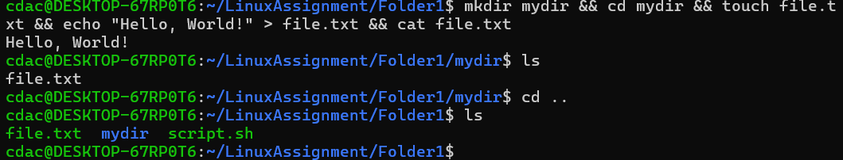

ls -l | grep ".txt"

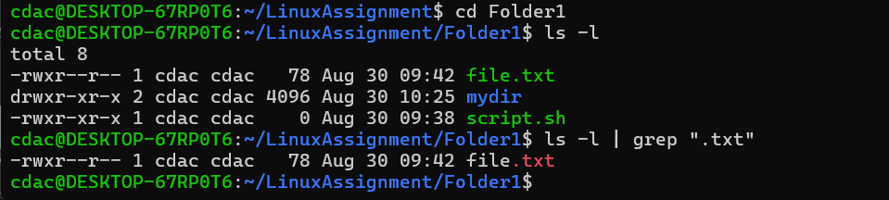

chmod 644 file.txt

This command sets file permissions to give the owner read and write access, and read-only access to everyone else

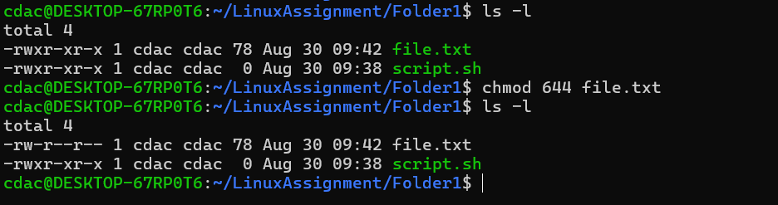

chmod u+x file.txt

This Command sets execute the file to the owner of the file

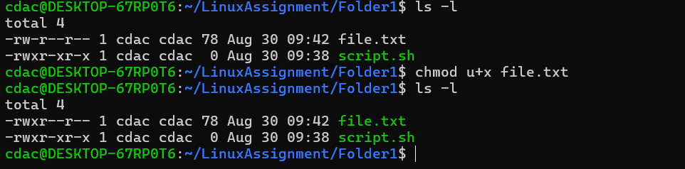

echo $PATH

displays the current value of the PATH variable in a Linux system

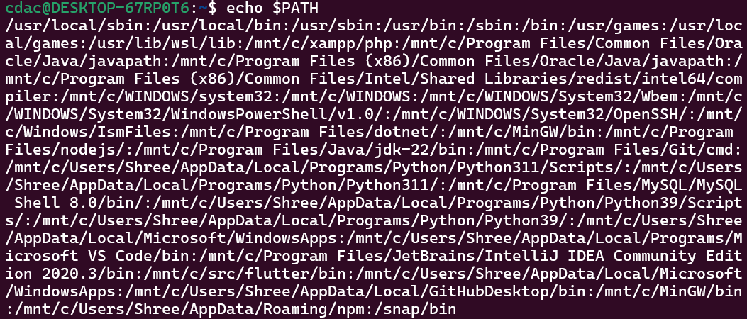

**Part B**

1. ls is used to list files and directories in a directory.

True

1. mv is used to move files and directories.

True

1. cd is used to copy files and directories.

False: cd is used to navigate through the directories.

And cp is used to copy files from current directory to other.

1. pwd stands for "print working directory" and displays the current directory.

True

1. grep is used to search for patterns in files.

True

1. chmod 755 file.txt gives read, write, and execute permissions to the owner, and read and execute permissions to group and others.

True

1. mkdir -p directory1/directory2 creates nested directories, creating directory2 inside directory1 if directory1 does not exist.

True

1. rm -rf file.txt deletes a file forcefully without confirmation.

True

Identify the Incorrect Commands:

1. chmodx is used to change file permissions.
2. cpy is used to copy files and directories.

Cp command is used to copy files and directories.

1. mkfile is used to create a new file.

Mkdir is used to make new directories

1. catx is used to concatenate files.

cat is used to concatenate files

1. rn is used to rename files.

**Part C**

Question 1: Write a shell script that prints "Hello, World!" to the terminal.



Question 2: Declare a variable named "name" and assign the value "CDAC Mumbai" to it. Print the

value of the variable.



Question 3: Write a shell script that takes a number as input from the user and prints it.

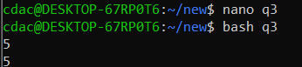

Question 4: Write a shell script that performs addition of two numbers (e.g., 5 and 3) and prints the

result.



Question 5: Write a shell script that takes a number as input and prints "Even" if it is even, otherwise

prints "Odd".

Question 6: Write a shell script that uses a for loop to print numbers from 1 to 5.

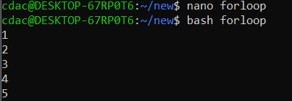

Question 7: Write a shell script that uses a while loop to print numbers from 1 to 5.

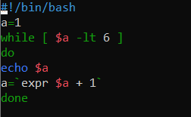

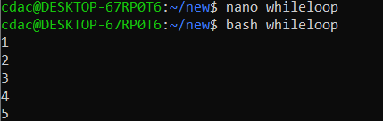

Question 8: Write a shell script that checks if a file named "file.txt" exists in the current directory. If it

does, print "File exists", otherwise, print "File does not exist".

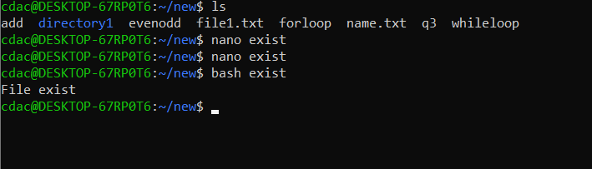

Question 9: Write a shell script that uses the if statement to check if a number is greater than 10 and

prints a message accordingly.

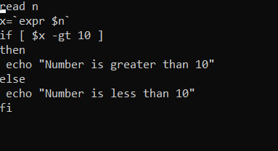

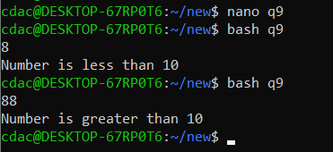

Question 10: Write a shell script that uses nested for loops to print a multiplication table for numbers

from 1 to 5. The output should be formatted nicely, with each row representing a number and each

column representing the multiplication result for that number.

Question 11: Write a shell script that uses a while loop to read numbers from the user until the user enters a negative number. For each positive number entered, print its square. Use the break statement to exit the loop when a negative number is entered.

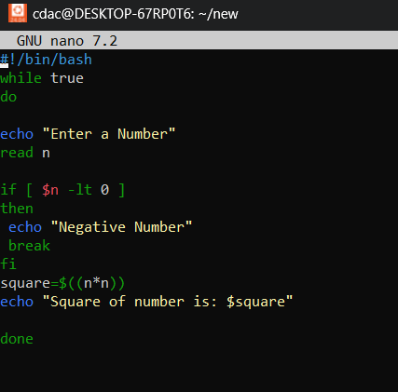

**Part E**

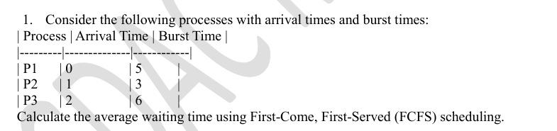

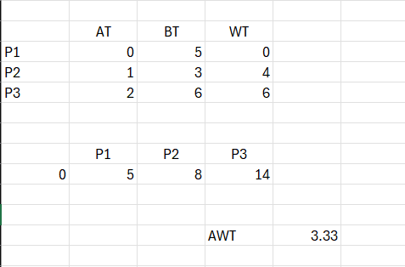

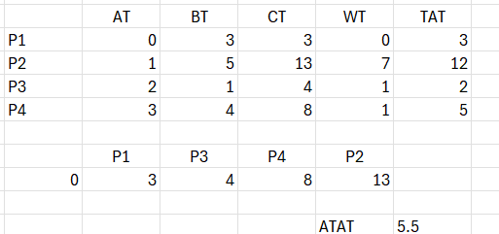

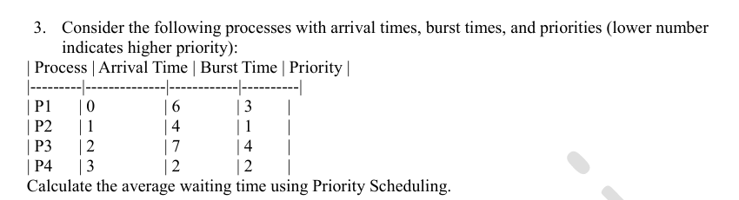

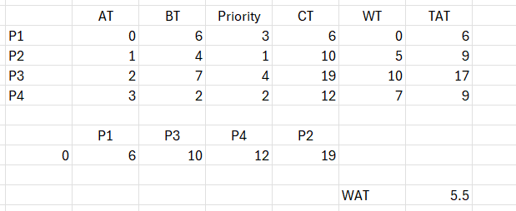

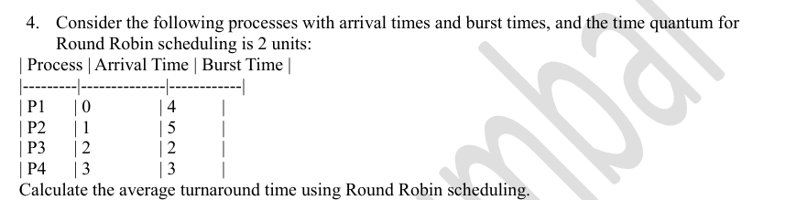

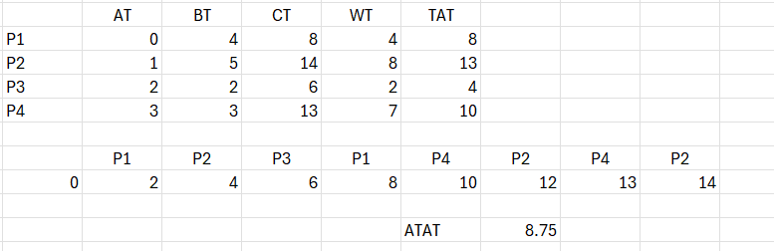

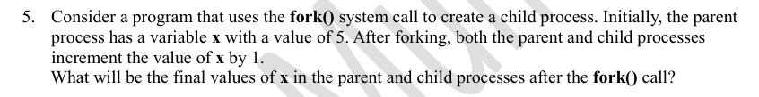

For this fork(), final value of x in parent will be 6 and for child will be 6.